Installing Docker 19.03:

sudo apt-get update

sudo apt-get install \

apt-transport-https \

ca-certificates \

curl \

gnupg-agent \

software-properties-common

curl -fsSL https://download.docker.com/linux/ubuntu/gpg | sudo apt-key add -

sudo apt-key fingerprint 0EBFCD88

sudo add-apt-repository \

"deb [arch=amd64] https://download.docker.com/linux/ubuntu \

$(lsb_release -cs) \

stable"

sudo apt update

sudo apt-get install docker-ce=5:19.03.0~3-0~ubuntu-bionic docker-ce-cli=5:19.03.0~3-0~ubuntu-bionic containerd.io

1.18.12-00

sudo apt-get -y install kubeadm=kubelet=1.18.12-00

sudo apt-get -y install kubeadm=1.18.12-00

sudo apt-get -y install kubectl=1.18.12-00 kubelet=1.18.12-00

kubeadm init --pod-network-cidr 192.168.0.0/16 --kubernetes-version “[v1.18.15](https://github.com/kubernetes/kubernetes/releases/tag/v1.18.15)”

mkdir -p $HOME/.kube

sudo cp -i /etc/kubernetes/admin.conf $HOME/.kube/config

sudo chown $(id -u):$(id -g) $HOME/.kube/config

kubectl apply -f <https://docs.projectcalico.org/v3.14/manifests/calico.yaml>

kubeadm upgrade plan

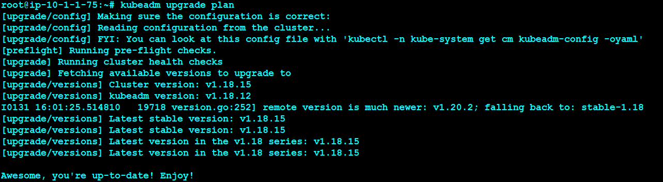

apt upgrade kubeadm=1.19.0-00

kubeadm upgrade plan

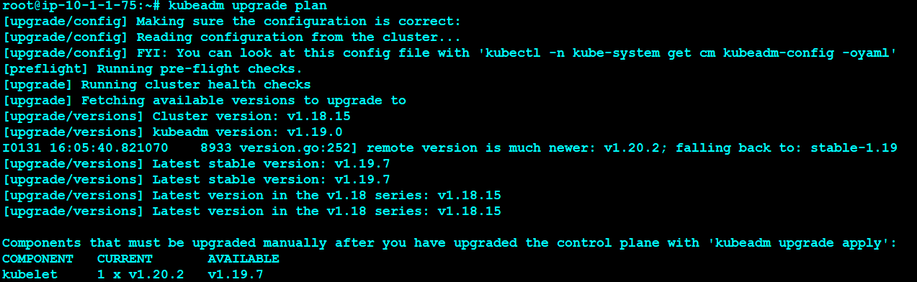

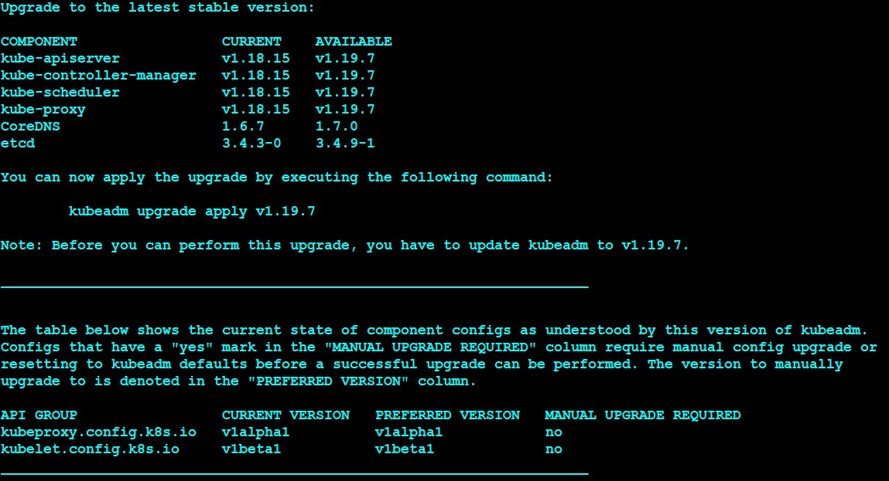

kubeadm upgrade apply v1.19.0



